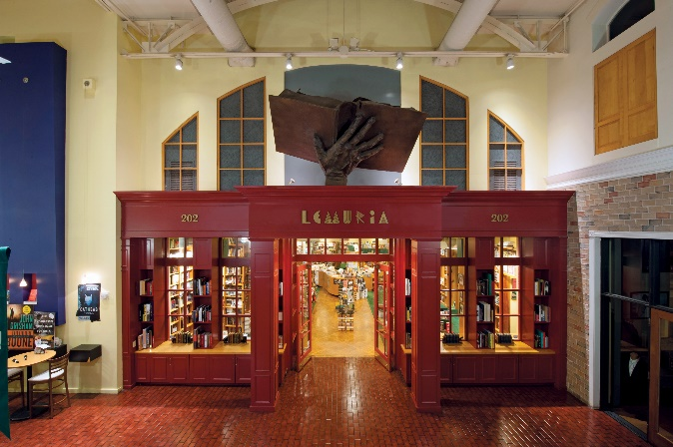
THE LEGEND OF LEMURIA

According to myth, the lost continent of Lemuria was once home to an advanced human civilization. The Lemurians possessed vast knowledge and great power, as well as the uncanny ability to communicate with one another through mental telepathy. But they were brazen and challenged the gods, who were displeased with their pride. As punishment, the gods took away the gift of telepathy and left them to devise new methods of communication. It was at this time that the Lemurians developed the world's first system of writing and began recording their thoughts in books.

MIAL 2020 Citation of Merit
Lemuria Books
by
John Evans

Lemuria, as a concept, was born in the summer of 1975 when Mel and I were twenty-four-year-old newlyweds. We were young, alternative counterculture types looking for a new way of life. With no training, just an idea, Lemuria just sort of happened. I’m not sure we even considered opening a bookstore to be a job. It was simply a calling. With hard work, the idea of Lemuria began to materialize, as almost all good things do if you get lucky.

For Mel and me, reading good books was not a problem. There are plenty. Figuring out how to share books, helping them find the right reader, and creating a business—that’s a different situation.

Baby Lemuria was a converted apartment on the second floor of a shopping center with a balcony facing a swamp. Luckily, we were located by Poets, the best music bar in Jackson at that time. About a hundred days after we opened on October 20, 1975, I was waiting tables at Poets to keep Lemuria’s doors open.

After two years of our pouring all extra cash into buying more books, Lemuria began its teenage life cycle with our move into Highland Village. During this time, new authors and more readers found our stacks. Eudora Welty, Ellen Gilchrist, Barry Hannah, Richard Ford, Walker Percy, Barry Moser, Willie Morris, and others all became good friends of the store. During the following years, we began to fulfill our mission of creating the best bookstore we could create in Jackson, Mississippi.
Author Eudora Welty

Later, great booksellers Valerie Walley and Tom Gerald became Lemurians, bringing with them new bookselling ideas. During the 1980s, Lemuria aged into adulthood and moved to Banner Hall on April Fool’s Day of 1988. Throughout the 1990s, more national friendships were formed. Among them were Jim Harrison, Robert Stone, Kent Haruf, Elmore Leonard, James Lee Burke, Pat Conroy, Mary Ward Brown, Tim O’Brien, Barry Gifford, and the devoted author John Grisham. All were great writers graciously sharing their gifts with our readers.

As middle age set in, so did the problems of change. As Amazon bloomed and Barnes and Noble attacked, Lemuria needed space to grow and expand. We created our Fiction Room to get a competitive edge and feature our friends’ literature. Shortly after, we added our events and web building to expand the Lemuria brand. As predictions of the end of physical books surfaced, spurred on by Kindle, Nook, and I-pad readers, we worked on branding the physical book with the motto “Read real books from a real bookstore.”
Author Angie Thomas

Over the years, our First Editions Club has been our backbone, bringing new authors to Mississippi and into the Lemuria family. We welcomed new friends. Among them were Charles Frazier, Jesmyn Ward, Rick Bragg, Greg Iles, Larry Brown, Ellen Douglas, Howard Bahr, Karl Marlantes, Jon Meacham, Ron Rash, Matthew Guinn, Katy Simpson Smith, Elizabeth Spencer, Natasha Trethewey, Angie Thomas, and many others.

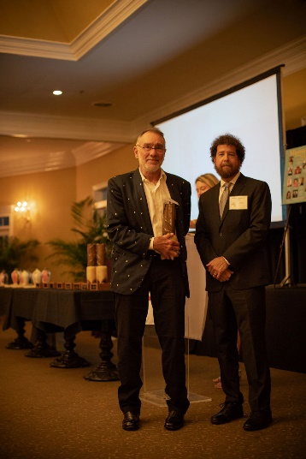
Teaming up with our soul brother Richard Howorth of Square Books, we became a brotherhood of two bookstores and developed a bigger mission. Together, we were able to put Mississippi on the national literary map.

Lemuria’s mission has always been to make books stand up and come alive by having authors visiting with readers and booksellers, touching, reading from, and signing physical books. That was our way to let the words sing forth.

Now, in our post-Covid elder years, Lemuria is moving forward once again to meet new challenges. Today, Lemuria is becoming more virtual, guided by two great booksellers, Lisa Newman and Hillary Taylor. We ask ourselves what’s next? A better bookstore, I hope. Our challenge continues with many of the same questions we faced in our early years. How do we bring the words to life? Will the authors visit Mississippi? Will new writers support our efforts? In this new virtual world, ordering books for e-readers and from Amazon seems so easy. The physical bookstore is facing a great challenge, but Lemuria feels ready to face this challenge head on.
John Evans and Jimmy Thomas at MIAL Banquet on June 12 in Pass Christian

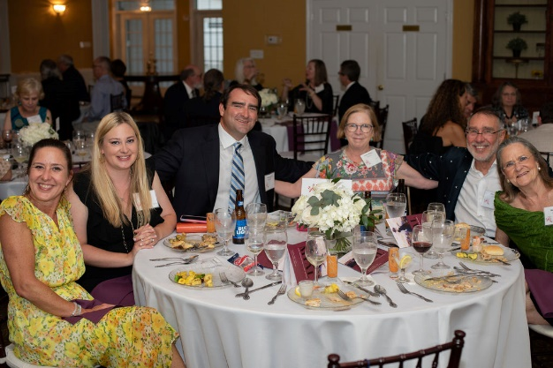
As I say thanks for this honor, I am humbled that you acknowledge Lemuria’s efforts and its being. But simply, I consider bookselling life to be just a different kind of artform. It’s a calling not unlike taking pictures that become photography books, creating paintings that emerge as an art book. Placing words on the page—poetry, fiction, or prose—all are art forms that just have to come out. Bookselling and book sharing are just things that have to be expressed. I have been so fortunate to live this dream, surrounded by authors, readers, and books, in the neighborhood I grew up in and where I raised my family.
(l to r) Saramel Evans, Laura Evans, Austin Evans, Valerie Walley, John and Mel Evans

Keep writing, expressing your creative outlet, and cheers to reading and to keeping bookstores alive!

