November 2022 Press Release
Mississippi Institute of Arts and Letters Welcomes New Board Members
The Mississippi Institute of Arts and Letters welcomed three new board members at its fall meeting. Each year the Mississippi Institute of Arts and Letters honors creative individuals with an award in their specific field. The prestigious awards, first made in 1980, have eight categories: Fiction, Non-fiction, Life Writing, Youth Literature, Visual Art, Music Composition (Classical), Music Composition (Contemporary), Photography, and Poetry. The Institute's juried competition is one of a kind in the state. Judges, chosen from out of state, are prominent in their field. Supported by Mississippi Institutes of Higher Learning and members, MIAL is privately funded, self-perpetuating, and non-profit.
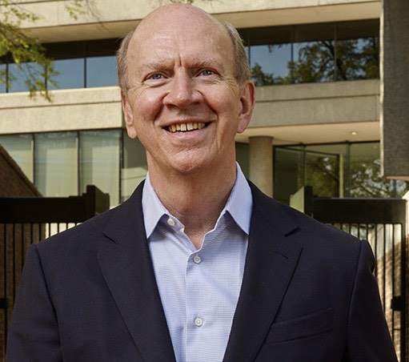
Robert Ivy of Columbus is an author, editor, and practicing architect. He has recently retired as the CEO of The American Institute of Architects (AIA). Ivy was formerly Editor-in-Chief of McGraw-Hill's Architectural Record prior to joining the AIA. Under Ivy's leadership, Architectural Record became the most widely disseminated architectural journal worldwide and garnered numerous awards, including the National Magazine Award for General Excellence. Ivy also led McGraw-Hill’s design and construction media during its explosive growth in China—where he launched a Mandarin version of Architectural Record—and the Middle East. Ivy’s authoritative biography Fay Jones: Architect was published in 2001 and is
Alan Karchmer, Washington DC, Photographer
now in its third edition. Ivy was previously honored by the national architecture fraternity Alpha Rho Chi, for his effectiveness in communicating the value of design. He shares the designation Master Architect with iconic architects such as Mies van der Rohe, Richard Buckminster Fuller, and I.M. Pei. He is one of seven to receive this honor in the fraternity’s 100-year history and the only architect selected in the 21st century. He has a BA in English from The University of the South, and an MA from Tulane University. In 2018 he was the recipient of MIAL’s Noel Polk Lifetime Achievement Award.
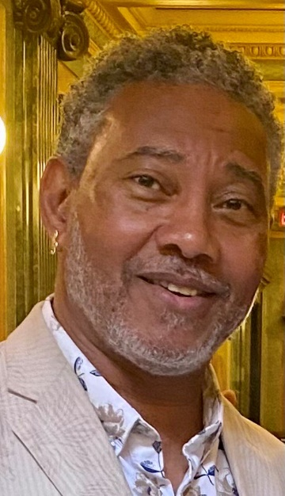
Dr. Alphonso Sanders of Cleveland is the retired Chair of Fine Arts and Director of the BB King Recording Studio at Mississippi Valley State University. He received degrees in music from Mississippi Valley State University, Valdosta State University, and the University of Mississippi. Dr. Sanders has performed at many recognized festivals including the Netherlands North Sea Jazz Festival; Montreux Switzerland Jazz Festival; Lucerne Switzerland Blues Festival; Mobile Jazz Festival; Ontario Canada Southside Shuffle Festival; and many of the Delta Blues Festivals. As a Fulbright Scholar, he studied in China exploring Chinese music and visual arts. He is recipient of the 2010 MAC Folk Arts Fellowship; the 2011 Mississippi Humanities Award and is published in Big City Rhythm & Blues magazine 2011. He is also an award winner in the 2009 and 2010 International Blues Challenge and was selected by the Delta Blues Society as the 2013 Blues Musician of the Year. His most recent recording projects are “Mississippi Influences” and “Twice As Nice.” For the past 30 years he has been involved in music composition and songwriting, covering various styles of jazz, blues, folk, gospel, and country and is currently involved with the HWY 80 Songwriters Festival, Meridian, MS as a facilitator and performer. He is the founder and host of First Thursday’s Jazz/Blues Night at the BB King Museum. At present, he is a traveling freelance musician, recording artist, and lecturer.
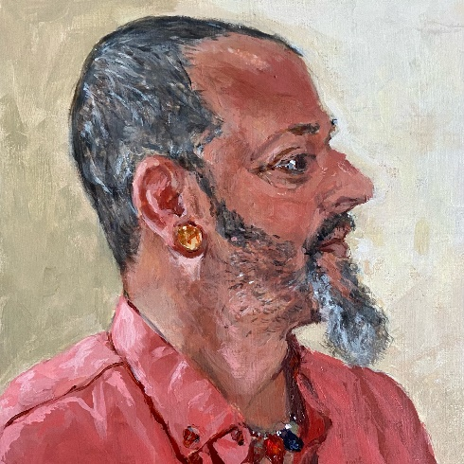
Alehandro Wooten of Hattiesburg has been the Executive Director of The Hattiesburg Arts Council since 2020. Before that he was the Arts Facilitator for the same organization for seven years. A native of Meridian, Wooten earned a BFA from the University of Southern Mississippi before conducting thirteen years of professional gallery work in Atlanta, Georgia. He later moved to Pensacola, Florida to pursue his interest in textiles and traditional beadwork before returning to Hattiesburg in 2014 to serve as arts facilitator for the Hattiesburg Arts Council. With a total of twenty-seven years of continuous professional art related employment, solo exhibitions, largescale public commissions, Wooten says of his current position: The Hattiesburg Art Council “holds a special place in my heart. I liken its efforts to the ones I experienced as a young person growing up in Meridian, Mississippi. At a crucial developmental point in my life, my artwork was chosen as first place in an art competition hosted by an organization similar to the HAC. This moment changed my life and gave me purpose.”
Portrait of Alehandra, Traci Stover

